 | HOLY CROSS COLLEGE  YEAR 11 EXAMINATION  SEMESTER 1, 2015  Question/Answer Booklet

Please place your student identification label in this box
Physics
ATAR 1/2

Student Name __________________________________________

Student’s Teacher __________________________________________

Time allowed for this paper
Reading time before commencing work: 10 minutes
Working time for paper: 3 hours

Materials required/recommended for this paper

To be provided by the supervisor
This Question/Answer Booklet
Stage 3 Physics Formulae and Data Sheet 2015

To be provided by the candidate
Standard items: pens, pencils, eraser, correction fluid, ruler, highlighters
Special items: drawing instruments, templates and non-programmable calculators satisfying the conditions set by the School Curriculum and Standards Authority for this course

Important note to candidates
No other items may be taken into the examination room. It is your responsibility to ensure that you do not have any unauthorised notes or other items of a non-personal nature in the examination room. If you have any unauthorised material with you, hand it to the supervisor before reading any further.
Structure of this paper

Section | Number of questions available | Number of questions to be answered | Suggested working time  (minutes) | Marks available | Percentage of exam
Section 1:  Short Answer | 12 | 12 | 50 | 45 | 34
Section 2:  Problem Solving | 5 | 5 | 75 | 68 | 51
Section 3:  Comprehension and Interpretation | 1 | 1 | 25 | 20 | 15
 |  |  |  |  | 100

Instructions to candidates

1. The rules for the conduct of examinations at Holy Cross College are detailed in the College Examination Policy. Sitting this examination implies that you agree to abide by these rules.

2. Write your answers in the spaces provided beneath each question. The value of each question is shown following each question.

3. You must be careful to confine your responses to the specific questions asked and to follow any instructions that are specific to a particular question.

4. Note that (where appropriate) answers should be given numerically, using scientific notation, and that they should be evaluated and not left in fractional or radical form. Choose an appropriate number of significant figures but usually no more than three.

5. Despite an incorrect final result, credit may be obtained for method and working, provided these are clearly and legibly set out.

6. Spare pages are included at the end of this booklet. They can be used for planning your responses and/or as additional space if required to continue an answer.
  - Planning: If you use the spare pages for planning, indicate this clearly at the top of the page.
  - Continuing an answer: If you need to use the space to continue an answer, indicate in the original answer space where the answer is continued, i.e. give the page number. Fill in the number of the question(s) that you are continuing to answer at the top of the page.

SECTION A: Short Answers

Marks Allotted: 45 marks out of a total of 133 marks (34%)

Attempt ALL 12 questions in this section. Answers are to be written in the space below or next to each question.

1. The Cassini space probe was successfully launched onboard a TITAN IV rocket from Cape Canaveral on October 15, 1997 on a voyage to Saturn. The diagram below shows the deployed space probe moving at a constant velocity of 890 ms⁻¹ towards A. To change course, firing the thruster produces a sideways force. This increases the velocity towards B from 0 to 60 ms⁻¹ in 25 seconds. Determine the resultant velocity after 25 s (remember that velocity is a vector quantity).
(4 marks)
A
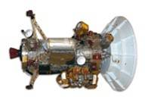
B
Thruster

…………………………………………………………………………………………………………

…………………………………………………………………………………………………………

…………………………………………………………………………………………………………

…………………………………………………………………………………………………………

…………………………………………………………………………………………………………

2. The diagram below shows a trampoline. Explain, in terms of momentum, why you do not hurt yourself when falling into the mat, but you would if you missed the mat and hit the ground?
(4 marks)
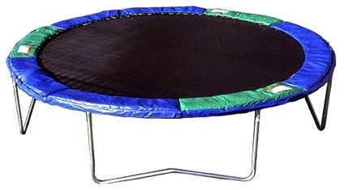
…………………………………………………………………………………………………………

…………………………………………………………………………………………………………

…………………………………………………………………………………………………………

…………………………………………………………………………………………………………

…………………………………………………………………………………………………………
3. Students are using model cars to test the effects of collisions on a frictionless track. A red car of mass 8.00 kg is moving East at 12.0 m s⁻¹ when it collides with a blue car of mass 5.00 kg travelling West at 9.00 m s⁻¹. After the collision the red car is moving East at
2.50 m s⁻¹ .
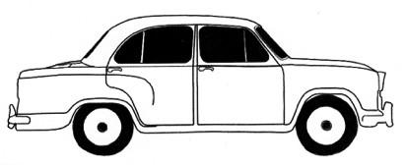
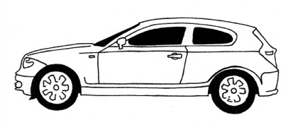
8.00 kg 12.0 m s⁻¹
5.00 kg 9.00 m s⁻¹

- Determine the velocity of the blue car after the collision. (2 marks)

…………………………………………………………………………………………………………

…………………………………………………………………………………………………………

…………………………………………………………………………………………………………

…………………………………………………………………………………………………………

- The kinetic energy of the cars after the collision is 121 J. Compare this with the kinetic energy of the cars before the collision. What conclusion can you make about energy transformations in the collision? (2 marks)

…………………………………………………………………………………………………………

…………………………………………………………………………………………………………

…………………………………………………………………………………………………………

…………………………………………………………………………………………………………

4. Collisions can be described as elastic or inelastic.

a) Explain the difference between the terms in italics.
(2 marks)

…………………………………………………………………………………………………………

…………………………………………………………………………………………………………

…………………………………………………………………………………………………………

…………………………………………………………………………………………………………

b) A golf club strikes a golf ball which then travels towards the green. What type of collision would this be and what evidence could you use to reinforce your answer?
(2 marks)

…………………………………………………………………………………………………………

…………………………………………………………………………………………………………

…………………………………………………………………………………………………………

…………………………………………………………………………………………………………

5. On hot summer days at the beach you can sometimes see people relaxing on a deck chair with a wet cloth over their forehead. Referring to heat energy concepts, explain how a wet cloth placed on the forehead can help a person stay cool.
(3 marks)

…………………………………………………………………………………………………………

…………………………………………………………………………………………………………

…………………………………………………………………………………………………………

…………………………………………………………………………………………………………

…………………………………………………………………………………………………………

…………………………………………………………………………………………………………

6. A blacksmith heated a 950 g stainless steel horseshoe in a furnace until it reached a temperature of 749°C. He plunged the horseshoe into 3.20 L of water. The final temperature of the steel and water mixture was 43.3°C when they reached thermal equilibrium.

Calculate the energy that transferred out of the horseshoe into the water.
(3 marks)

…………………………………………………………………………………………………………

…………………………………………………………………………………………………………

…………………………………………………………………………………………………………

…………………………………………………………………………………………………………

…………………………………………………………………………………………………………

…………………………………………………………………………………………………………

7. If a thin walled drinking glass (such as a wine glass) is dipped into very hot water the glass often cracks.

Referring to the principles of Kinetic Molecular Theory, explain why this happens.
(3 marks)

…………………………………………………………………………………………………………

…………………………………………………………………………………………………………

…………………………………………………………………………………………………………

…………………………………………………………………………………………………………

…………………………………………………………………………………………………………

8. A flea can jump incredible heights relative to its own size, resulting in one of the most impressive examples of acceleration in the animal kingdom. By pushing its legs against the ground, the flea can attain an upward velocity of 1.20 ms⁻¹ in 1.10 x 10⁻³ s. Calculate the flea’s average acceleration over this time.
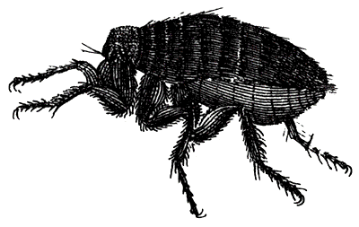
(3 marks)

…………………………………………………………………………………………………………

…………………………………………………………………………………………………………

…………………………………………………………………………………………………………

…………………………………………………………………………………………………………

…………………………………………………………………………………………………………

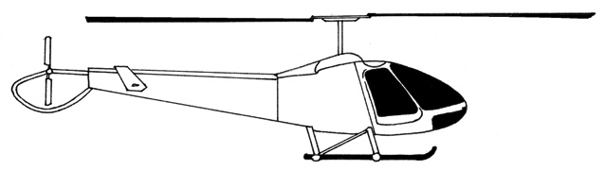
20.8°
Force from rotors acts at an angle of 20.8° to the vertical
A helicopter of mass 3100 kg is kept at a constant height and propelled forwards by a single force from its rotors acting at an angle of 20.8 ° to the vertical.

- Draw a vector diagram and determine the magnitude of the force from the rotors.
9.

(3 marks)

b) Calculate the work done by the force from the rotors to move the helicopter horizontally forwards by a distance of 65.0 m.

(If you could not solve part a) let the force from the rotors = 3.00 × 10⁴ N)

(2 marks)

…………………………………………………………………………………………………………

…………………………………………………………………………………………………………

…………………………………………………………………………………………………………

…………………………………………………………………………………………………………
10. A student was asked to measure the diameter of a spherical steel ball in order to calculate its volume for a density calculation. She recorded the measurement as 1.2 ± 0.2 cm.

(a) Express the uncertainty as a percentage uncertainty.
(2 marks)

…………………………………………………………………………………………………………

…………………………………………………………………………………………………………

…………………………………………………………………………………………………………

…………………………………………………………………………………………………………

(b) Determine the volume of the steel sphere, expressing the answer with the appropriate significant figures and absolute error.
(3 marks)

…………………………………………………………………………………………………………

…………………………………………………………………………………………………………

…………………………………………………………………………………………………………

…………………………………………………………………………………………………………

11. During an Olympic power-lifting event, Ryan manages to snatch 140.0 kg from the floor to 2.10 m above the floor (and over his head) in a total time of 1.80 s. Determine the average power generated by Ryan during this lift.
(3 marks)

…………………………………………………………………………………………………………

…………………………………………………………………………………………………………

…………………………………………………………………………………………………………

…………………………………………………………………………………………………………

…………………………………………………………………………………………………………

12. An aeroplane has just taken off from the runway. Draw a free body diagram to show all the forces which act on the plane, indicating which of the forces will be largest.
(4 marks)

End of Section 1
SECTION B: Problem Solving

Marks Allotted: 68 marks out of a total of 133 marks (51%)

Attempt ALL 5 questions in this section. Answers are to be written in the space below or next to each question.

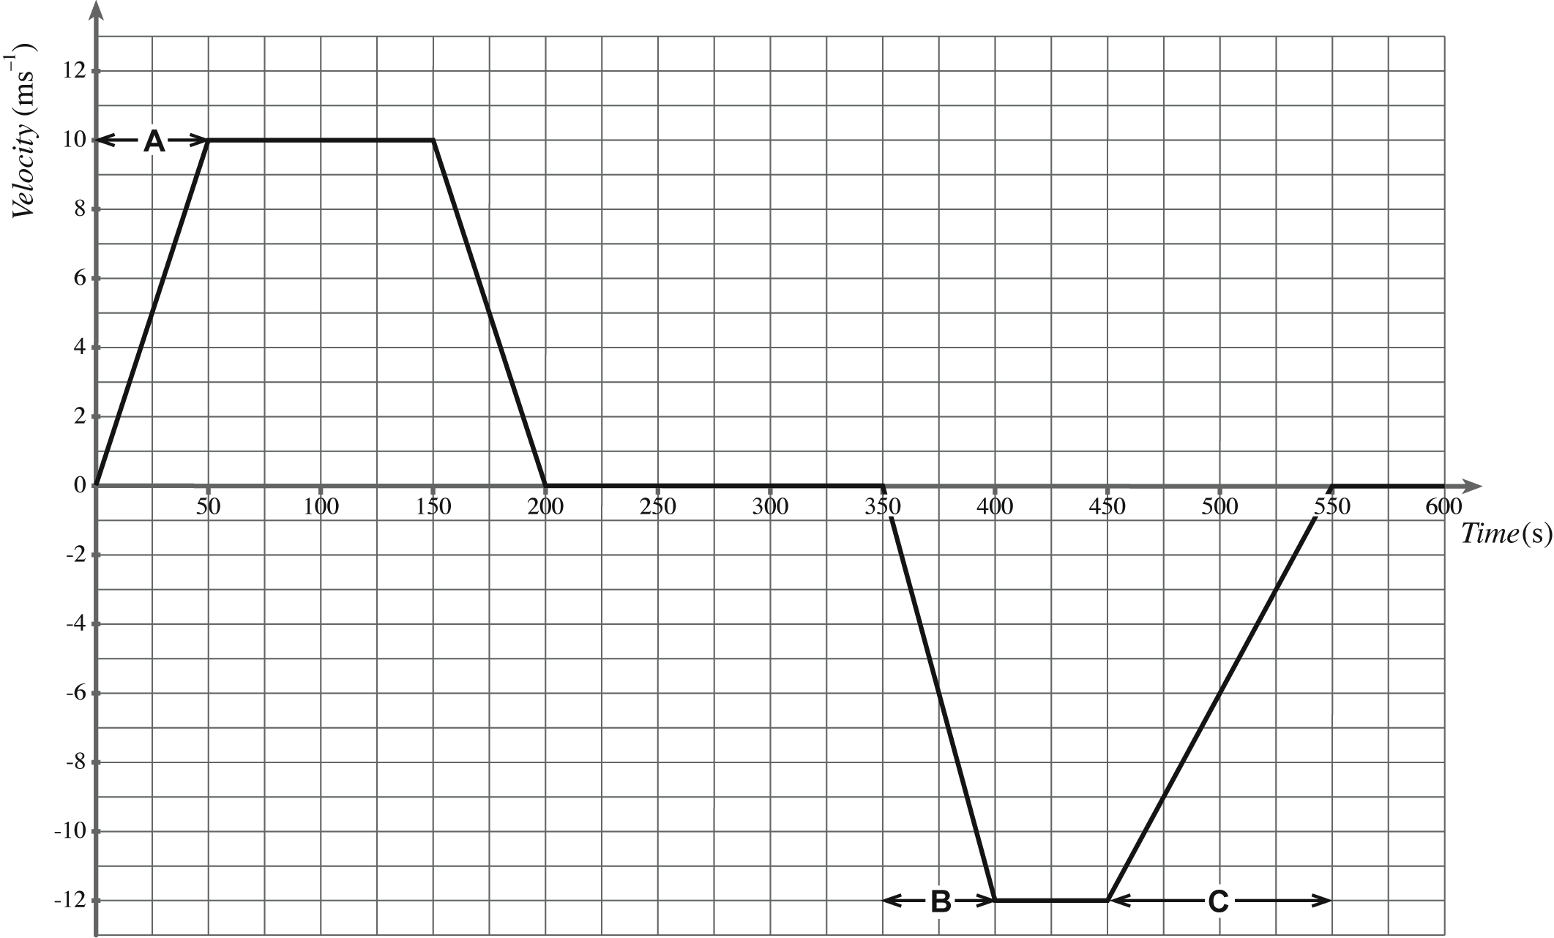
1. [10 marks]
On a school ski trip, a mini-bus transports passengers between the car park and the ski centre. The bus starts from the car park and travels north to the ski centre, drops off the passengers and returns to the car park. The velocity–time graph for the bus journey is given below.
Time (s)
Velocity
(ms⁻¹)

a). The time taken by the bus to travel from the car park to the ski centre is 200 seconds.
Use the graph to calculate the distance travelled by the bus from the car park to the ski centre. Show all working on the graph and in the space below.
(2 marks)

…………………………………………………………………………………………………………

…………………………………………………………………………………………………………

…………………………………………………………………………………………………………

…………………………………………………………………………………………………………

…………………………………………………………………………………………………………

b). Show that the acceleration of the bus during section A of its journey is 0.20 ms^{–2}.
(1 mark)

…………………………………………………………………………………………………………

…………………………………………………………………………………………………………

c). The mass of the bus is 2250 kg. The combined mass of the driver and its nine passengers is 800 kg. Calculate the force required to produce the acceleration of 0.20 ms^{–2} during section A of its journey.
(1 mark)
…………………………………………………………………………………………………………

…………………………………………………………………………………………………………

After unloading the passengers at the ski centre, the bus returns to the car park with some tourists.
d). Explain why the second part of the graph is drawn below the time axis.
(1 mark)

…………………………………………………………………………………………………………

…………………………………………………………………………………………………………

…………………………………………………………………………………………………………

e). Describe the motion of the bus during section B of its journey. (1 mark)
…………………………………………………………………………………………………………

…………………………………………………………………………………………………………
f). The unbalanced force acting on the bus during section C of its journey is 347N.
Estimate the number of passengers in the bus. (4 marks)

…………………………………………………………………………………………………………

…………………………………………………………………………………………………………

…………………………………………………………………………………………………………

…………………………………………………………………………………………………………

…………………………………………………………………………………………………………

…………………………………………………………………………………………………………

…………………………………………………………………………………………………………

…………………………………………………………………………………………………………

…………………………………………………………………………………………………………

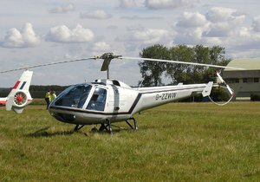
2. [15 marks]
A helicopter such as the one shown opposite has a mass of 5000 kg and is sitting on the ground with its engines idling, producing a lift force of 1.60 x 10⁴ N.
a). Calculate the normal reaction force of the ground on the helicopter.
(2 marks)
…………………………………………………………………………………………………………

…………………………………………………………………………………………………………

…………………………………………………………………………………………………………

…………………………………………………………………………………………………………

…………………………………………………………………………………………………………

b). The pilot now increases the speed and tilt of the rotors, so that the lift force becomes
6.0x10⁴ N. Calculate the upwards acceleration of the helicopter.
(3 marks)
…………………………………………………………………………………………………………

…………………………………………………………………………………………………………

…………………………………………………………………………………………………………

…………………………………………………………………………………………………………

…………………………………………………………………………………………………………

…………………………………………………………………………………………………………

…………………………………………………………………………………………………………

…………………………………………………………………………………………………………

c). If the helicopter continues to accelerate at this rate, how long will it take to reach a height of
350m?
(2 marks)
…………………………………………………………………………………………………………

…………………………………………………………………………………………………………

…………………………………………………………………………………………………………

…………………………………………………………………………………………………………

…………………………………………………………………………………………………………

d). What will be its speed at 350m altitude? (2 marks)
…………………………………………………………………………………………………………

…………………………………………………………………………………………………………

…………………………………………………………………………………………………………

…………………………………………………………………………………………………………

…………………………………………………………………………………………………………

…………………………………………………………………………………………………………
Just as the helicopter reaches the height of 350m, a loose bolt dislodges from its undercarriage and eventually falls to the ground below.
e). In which direction does the bolt move initially? (1 mark)
…………………………………………………

f). Calculate how long the bolt takes to reach the ground. (3 marks)
…………………………………………………………………………………………………………

…………………………………………………………………………………………………………

…………………………………………………………………………………………………………

…………………………………………………………………………………………………………

…………………………………………………………………………………………………………

…………………………………………………………………………………………………………

…………………………………………………………………………………………………………

…………………………………………………………………………………………………………

g). With what speed does the bolt actually strike the ground? (2 marks)

…………………………………………………………………………………………………………

…………………………………………………………………………………………………………

…………………………………………………………………………………………………………

…………………………………………………………………………………………………………

…………………………………………………………………………………………………………

- [16 marks]
A 0.680 kg solid sample of an unknown substance is heated slowly while inside an insulated
container. The graph below illustrates the heating curve of this substance.
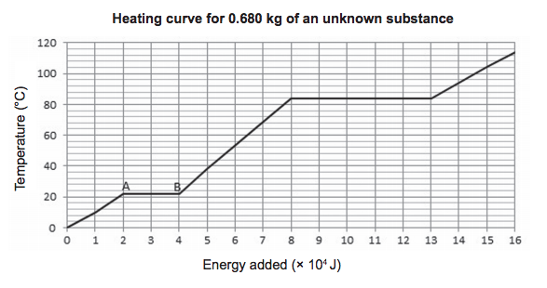
a). State the temperature at which:

(i) the substance boils. (1 mark)

Answer: ………………………

(ii) the substance melts. (1 mark)

Answer: ……………………….

b). Calculate the latent heat of vaporisation of this substance, and give the correct units.
(4 marks)

…………………………………………………………………………………………………………

…………………………………………………………………………………………………………

…………………………………………………………………………………………………………

…………………………………………………………………………………………………………

…………………………………………………………………………………………………………

…………………………………………………………………………………………………………

…………………………………………………………………………………………………………

c). Explain why the temperature remains constant between Points A and B on the graph, even though energy has been added. Your answer should demonstrate your understanding of phase change and temperature at a particle level.
(6 marks)
…………………………………………………………………………………………………………

…………………………………………………………………………………………………………

…………………………………………………………………………………………………………

…………………………………………………………………………………………………………

…………………………………………………………………………………………………………

…………………………………………………………………………………………………………

…………………………………………………………………………………………………………

…………………………………………………………………………………………………………

…………………………………………………………………………………………………………

…………………………………………………………………………………………………………

…………………………………………………………………………………………………………

…………………………………………………………………………………………………………

…………………………………………………………………………………………………………

d). Calculate the specific heat capacity of this substance in the liquid phase.
(4 marks)

…………………………………………………………………………………………………………

…………………………………………………………………………………………………………

…………………………………………………………………………………………………………

…………………………………………………………………………………………………………

…………………………………………………………………………………………………………

…………………………………………………………………………………………………………

…………………………………………………………………………………………………………

…………………………………………………………………………………………………………

…………………………………………………………………………………………………………

4. [9 marks]

A dart of mass 50g is thrown at the suspended block of wood, mass 5.0kg as shown.
After the collision, the dart embeds itself into the wooden block which rises 20cm as
a result.

a). Assuming all of the kinetic energy immediately following the impact of the dart into
the wooden block is converted into potential energy (i.e. air resistance is negligible),
calculate the initial velocity of the block as it begins swinging.
(3 marks)

…………………………………………………………………………………………………………

…………………………………………………………………………………………………………

…………………………………………………………………………………………………………

…………………………………………………………………………………………………………

b). Use the conservation of momentum to calculate the initial velocity of the dart.
(3 marks)

…………………………………………………………………………………………………………

…………………………………………………………………………………………………………

…………………………………………………………………………………………………………

…………………………………………………………………………………………………………

c). Show, using appropriate calculations, that the collision is inelastic.
(3 marks)

…………………………………………………………………………………………………………

…………………………………………………………………………………………………………

…………………………………………………………………………………………………………

…………………………………………………………………………………………………………

5. [18 marks]
Pat often makes a hot cup of tea. She brings the water to the boil at 100 ºC and adds it to the tea leaves. As the tea brews for a few minutes, it cools to 90.0 ºC. This is still too hot to drink so Pat pours the tea into a cup and blows on the surface of the tea until it cools to 65.0 ºC.
a). Define the term ‘internal energy’.

(2 marks)

…………………………………………………………………………………………………………

…………………………………………………………………………………………………………

…………………………………………………………………………………………………………

…………………………………………………………………………………………………………

b). Calculate the heat energy lost to the environment as 0.250 kg of tea in the cup cooled down from 90.0 ºC to 65.0 ºC. Assume that the specific heat capacity of tea is the same
as that for water.
(2 marks)
…………………………………………………………………………………………………………

…………………………………………………………………………………………………………

…………………………………………………………………………………………………………

…………………………………………………………………………………………………………

c). Use the kinetic theory to explain why blowing on the surface of the tea helps the tea to
cool down quickly.
(5 marks)
…………………………………………………………………………………………………………

…………………………………………………………………………………………………………

…………………………………………………………………………………………………………

…………………………………………………………………………………………………………

…………………………………………………………………………………………………………

…………………………………………………………………………………………………………

…………………………………………………………………………………………………………

…………………………………………………………………………………………………………

…………………………………………………………………………………………………………

On hot days, Pat makes iced tea by adding ice cubes at 0.00 °C to the pot of freshly brewed tea, cooling it from 90.0 ° to 0.00 °C.

d). If the amount of liquid in the teapot was 0.250 kg, calculate the difference in internal energy between tea at 90.0 °C and iced tea at 0.00 °C.
(2 marks)
…………………………………………………………………………………………………………

…………………………………………………………………………………………………………

…………………………………………………………………………………………………………

…………………………………………………………………………………………………………

…………………………………………………………………………………………………………
Just as the helicopter reaches the height of 350m, a loose bolt dislodges from its undercarriage and eventually falls to the ground below.
e). Calculate the mass of ice, in kilograms, that has to be added to the tea in the pot in
Part (d) to bring the temperature of the liquid down to 0.00 ºC. Assume no loss of heat to the surroundings. Show all workings.
(4 marks)

…………………………………………………………………………………………………………

…………………………………………………………………………………………………………

…………………………………………………………………………………………………………

…………………………………………………………………………………………………………

…………………………………………………………………………………………………………

…………………………………………………………………………………………………………

…………………………………………………………………………………………………………

f). In the real world, Pat would not need to add as much ice to the tea as calculated in Part (e) above. Using your understanding of heat transfer, explain why this is so.
(3 marks)
…………………………………………………………………………………………………………

…………………………………………………………………………………………………………

…………………………………………………………………………………………………………

…………………………………………………………………………………………………………

…………………………………………………………………………………………………………

SECTION C: Comprehension and Interpretation. This section contains 1 question and is worth 15% (20 marks out of 133) of the marks for the examination. Answer all questions in this section.
Pole vaulting can be seen as a series of stages. Run up - pole carried horizontally; going up – pole flexed; top - body over bar, pole straight; coming down -pole falling away; landing on large cushioned landing pad - pressed down by body.
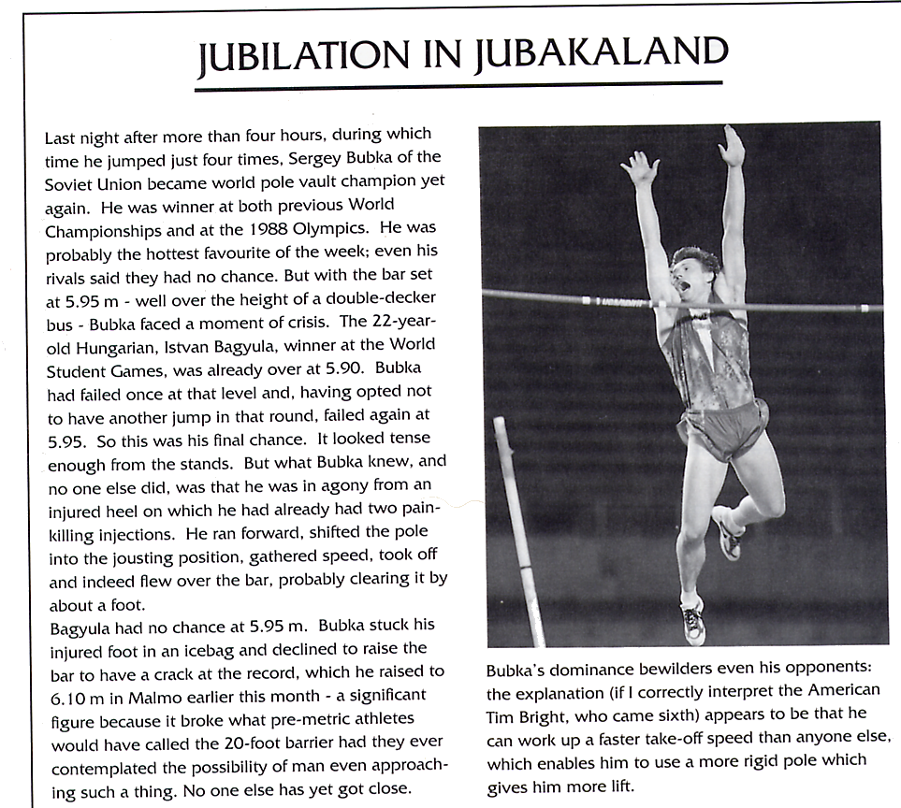
a). Describe the energy changes that are occurring during each stage of the pole vault.
(5 marks)
b). Sketch a graph to illustrate how the pole vaulter's potential energy changes with time
during the pole vault. Mark on the position of the pole vaulter at significant points.
(3 marks)
Energy

time
c). On the same graph show how the pole vaulter's kinetic energy changes with time.
(2 marks)
d). Estimate the maximum potential energy that Bubka gains during the world record vault.
(3 marks)
e). Do you think his maximum kinetic energy would be greater or less than this? (1 mark)
………………………………………………………………………………………………....
f). Where does the extra energy go and why can't the energy just disappear? (2 marks)
g). In the article the comment is made that the champion pole vaulter achieves a much faster
take-off speed than his rivals and this means that he can use a much stiffer pole.

i). How does the faster take-off speed help? (2 marks)
ii). Why do you think using a stiffer pole is an advantage? (2 marks)
END OF PAPER

